EXP 1: Analysis, Development and Verification of 8-bit and 16-bit Arithmetic Operations Using Assembly Language Program

- Addition of 8–bit :
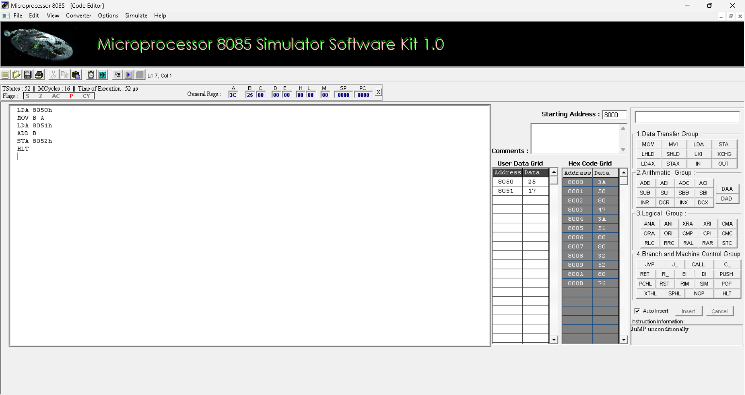

- Subraction of 8-bit:
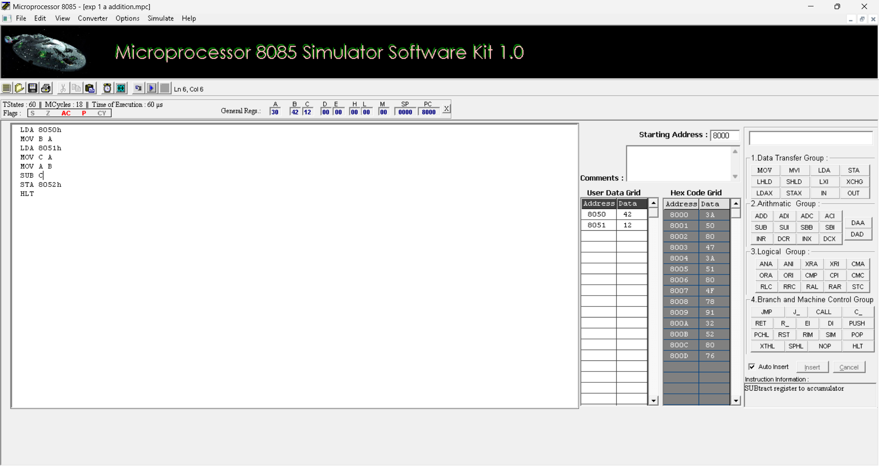

- Multiplication of 16-bit:
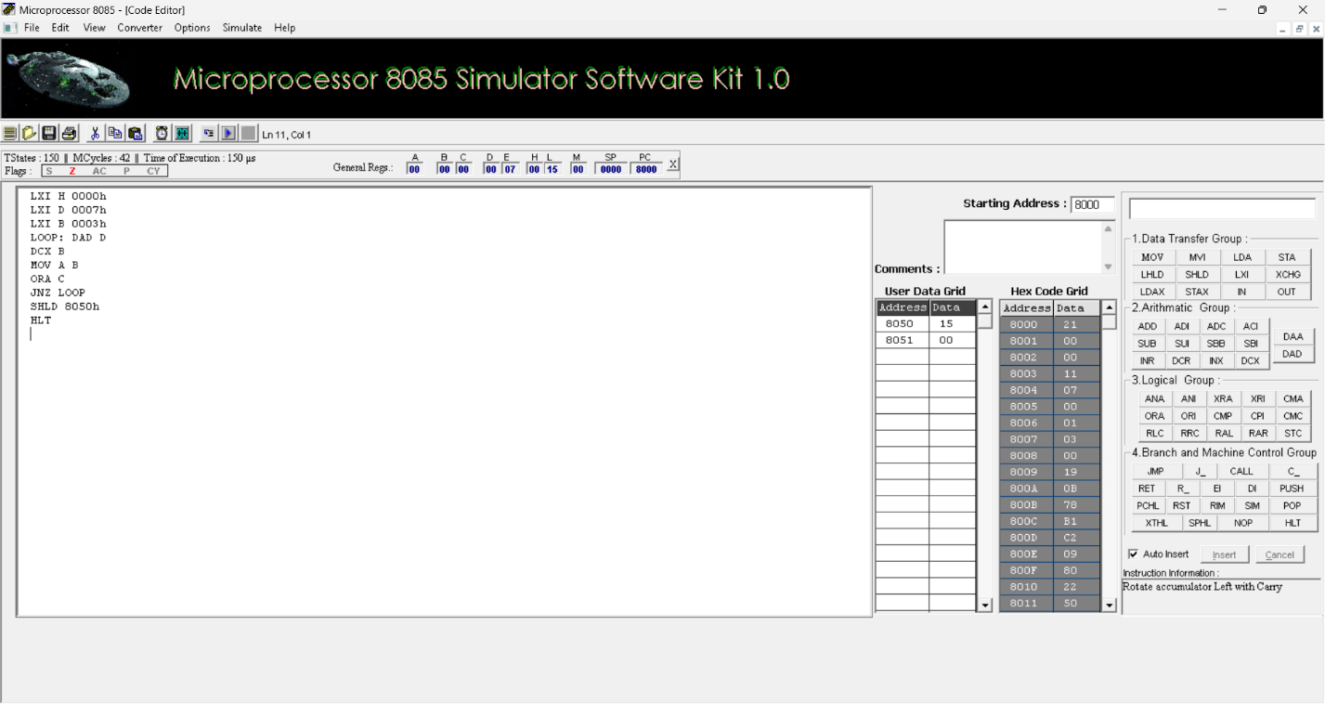

- Division of 16-bit:

